CS 255 System Design Document Template

This template lays out all the different sections that you need to complete for Project Two. Each section has guidance to prompt your thinking. You will need to continually reference the interview transcript as you work to make sure that you are addressing your client’s needs. There is no required length for the final document. Instead the goal is to complete each section based on what your client’s needs are. Remove this note when you are finished, and replace all bracketed text with the relevant information.

UML Diagrams

UML Use Case Diagram
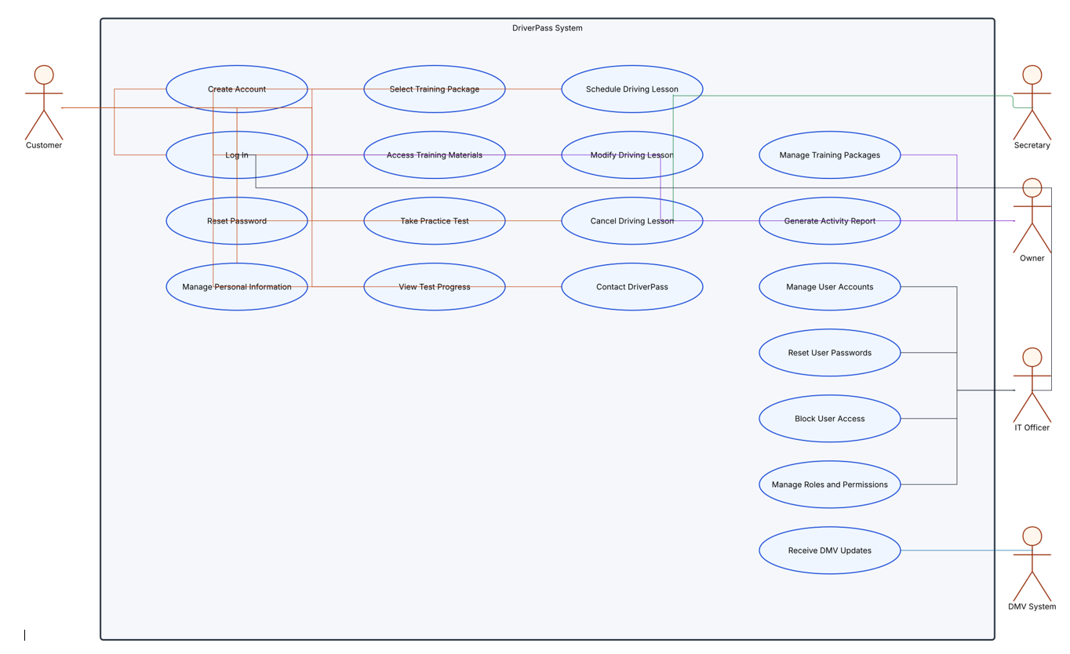

UML Activity Diagrams

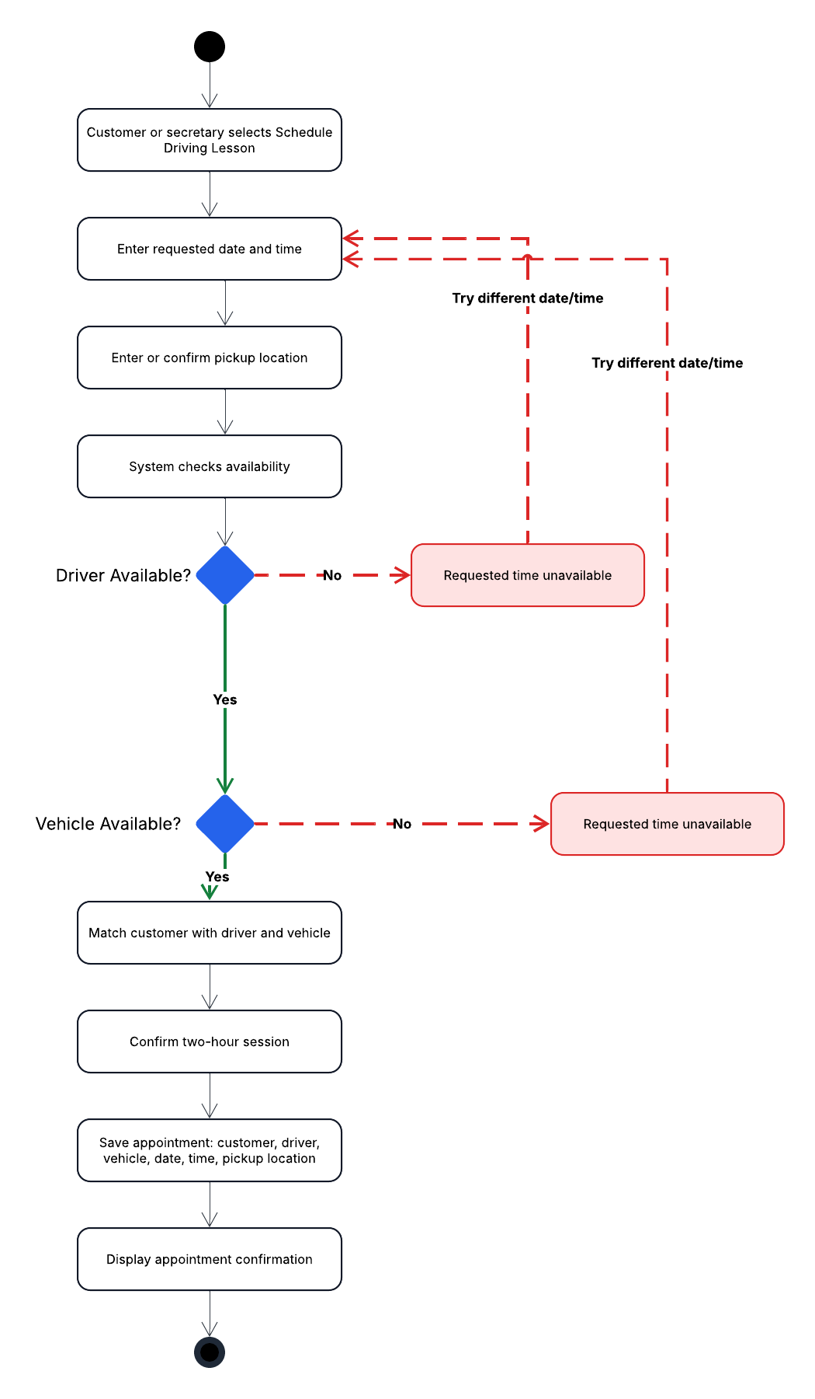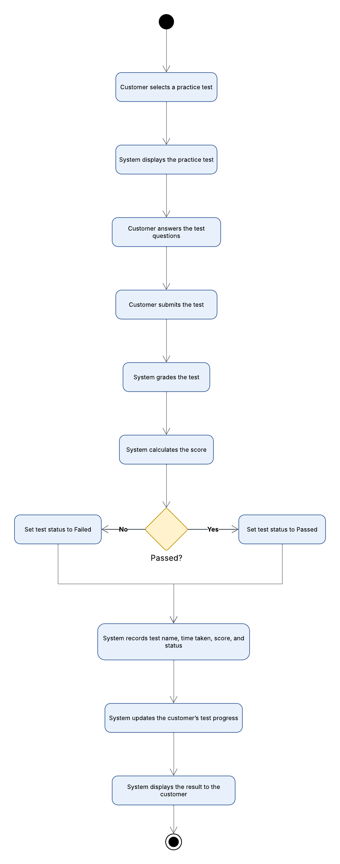

UML Sequence Diagram
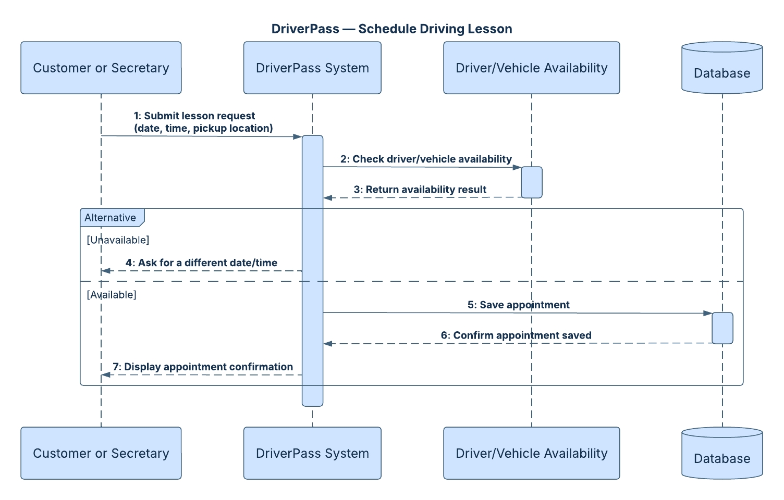

UML Class Diagram
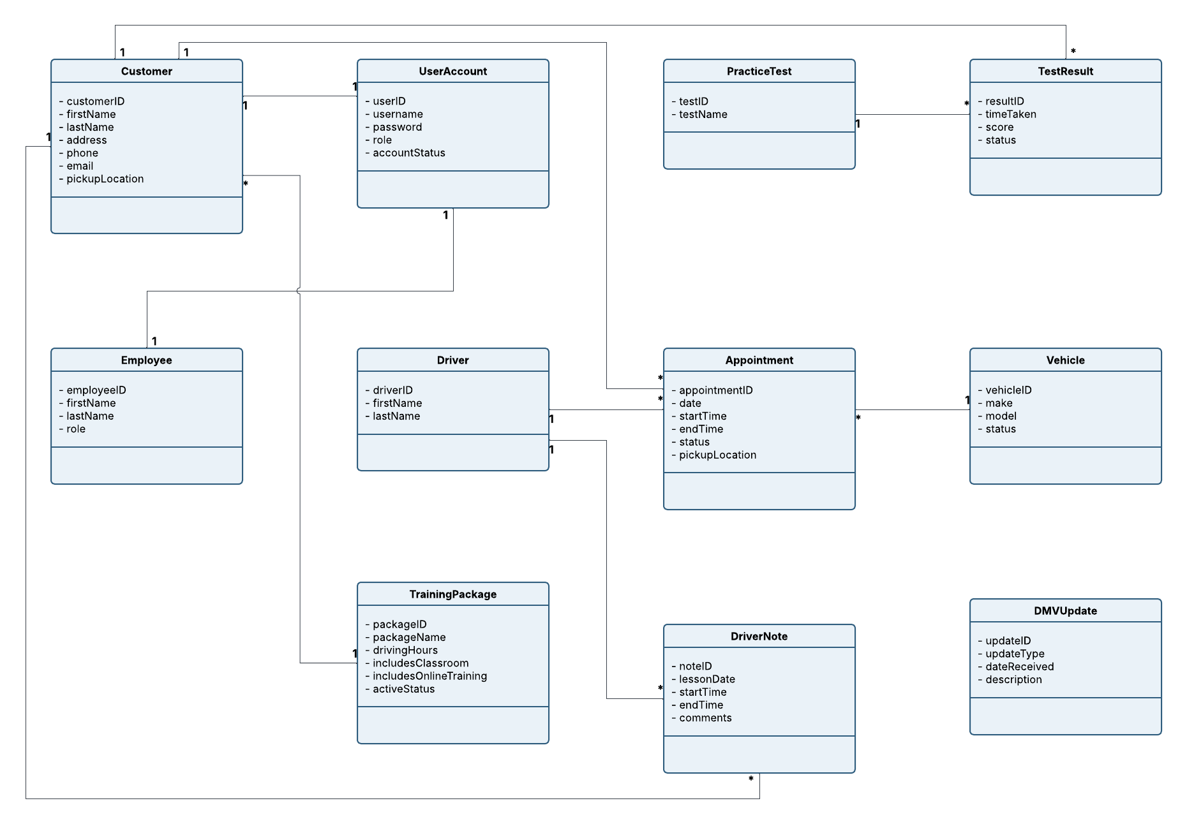

Technical Requirements

- The DriverPass system should be web based so customers and employees can access it from computers and mobile devices using a standard web browser.
- The system should be hosted in the cloud so DriverPass does not have to maintain its own servers, backups, or other infrastructure.
- A centralized database will be required to store customer accounts, employee accounts, appointments, driver and vehicle information, training packages, practice test results, driver notes, and system activity.
- The system should require a reliable internet connection for users to create, modify, or update records. Reports and selected information may be downloaded for offline use.
- The system should support secure user authentication with unique usernames and passwords, role based permissions, password resets, account blocking, and protection against repeated failed login attempts.
- Secure network connections should be used to protect customer and payment information when information is transmitted between the user’s device and the system.
- The system should support current desktop and mobile web browsers so users do not need separate versions of the application for different operating systems.
- DriverPass employees will need standard computers or mobile devices with internet access. No specialized hardware should be required beyond the company’s existing devices and network equipment.
- The system should include tools for monitoring account activity and generating reports so the owner can identify who created, modified, or canceled reservations.
- The system will need a way to receive updates from the DMV so DriverPass can keep its rules, policies, and sample practice questions current.
- The cloud environment should provide routine backups, system availability, and recovery capabilities to reduce downtime and limit the amount of technical maintenance DriverPass must perform.
- Development and maintenance tools should support future updates to the system, including changes to training packages, user roles, and additional system features.

